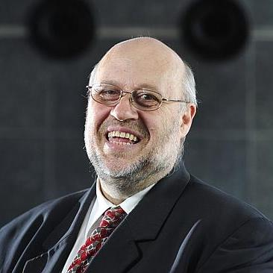
Mark was awarded the RACGP Australian GP of the Year Award (2013) in recognition of his commitment to the profession and has received a 35 year long service medal for rural practice in South Australia. He was awarded a Paul Harris Fellowship (2017), given by Rotary International in recognition for contributed services in keeping with the principles of Rotary International.
He is a recipient of the McCleave Thompson award for contribution to the SANT Faculty of the RACGP. He delivered the RACGP’s William Arnold Connolly oration at GP18 ASC and in 2019 received the RACGP’s highest honor the Rose-Hunt Award.
His work Internationally has led to Honorary Fellowships of the Malaysian Academy of Family Physicians, the Fijian College of General Practice and Honorary Fellowship of the Hong Kong College of Family Physicians and was honored to deliver the HKCFP’s 31st Sun Yat Sen oration in 2021.
Mark's interests include music, photography, origami and is a keen gardener with partner Beth.

