“HIGH QUALITY HEALTHCARE FOR ALL”
9 Crocker Street GOOLWA SA 5214
Ph: 08 8555 2404
Fx: 08 8555 1002

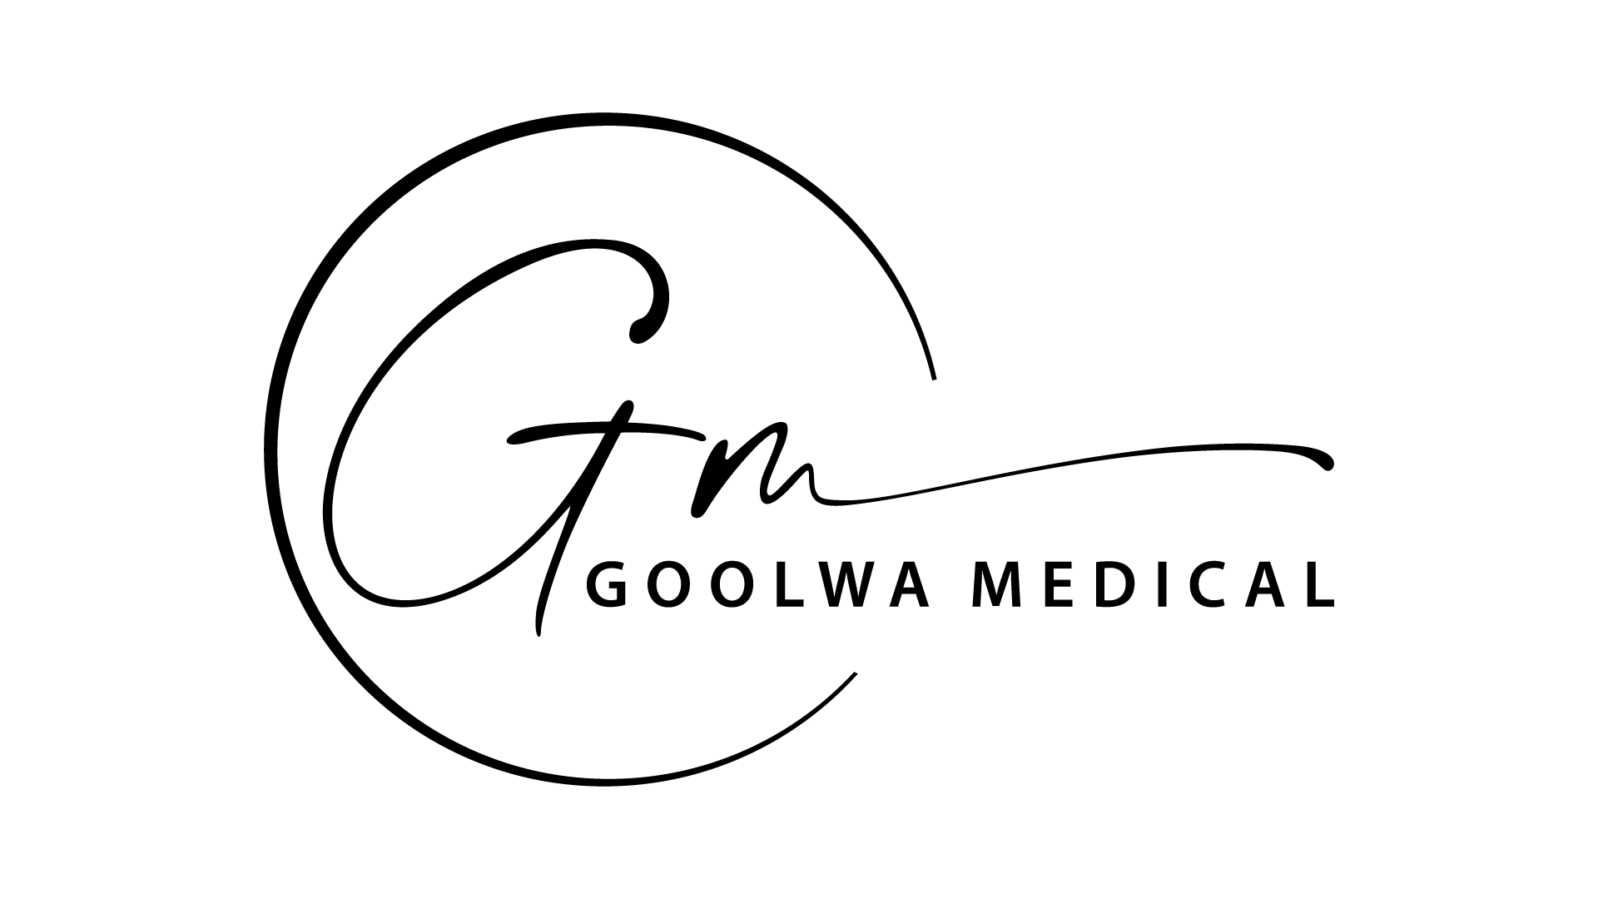

Survey Feedback

We listened to your feedback

As a result, we’re taking active steps to better your patient experience

At Goolwa Medical Centre we carried out a patient survey (the Practice Accreditation and Improvement Survey) and asked for your honest opinion on the service we provide. We listened to your concerns and have taken the following actions to make improvements to patient care where you feel it would be most useful:
What you told us | Efforts we are making
- Waiting times are too long to see the doctor of your choice. | Our staff will encourage you to book appointments, where possible, in advance. i.e. before leaving the practice after visiting your doctor. We realise this is not always possible, however, regular script or check up appointments can be made this way.  We’d love to have extra doctors, but we are at capacity at the moment and unfortunately it is quite difficult to entice GP’s to the rural areas. 😊
- Waiting time in the surgery | Reception staff will make every effort to contact patients when a doctor is running over 30 minutes late, before they attend the clinic.  Should the delay occur whilst the patient is in the waiting room, reception staff, in some cases, may be able to contact the doctor for an ETA. However, emergency situations will not allow this.  We do discuss these issues regularly at meetings, however, sometimes the days just don’t go as planned. 😊

